22/04/16
Regent’s University London
08
Fall
Written by: Arnaldo Bernardo

Supervised by: Jacob H. Schmidt

DIS6A1 – Global Financial Management Dissertation

Regent’s University London

The impact of the introduction of the Euro on the equity risk premium of Italian stocks

Dedications

I want to dedicate this dissertation to my father that with his success in life inspired me to always challenge myself to achieve the best. A special dedication goes also to my friend and colleague Daniel Babes whose impressive dedication to work will motivate me during my entire career.

Acknowledgment

I whish to tank all the people that with their direct and indirect actions helped me in to gain grate results in the academic career.
First of all, I want to express my gratitude to my respected supervisor Mr. Jacob Schmidt that always pushed me to find an answer when encountering problems and that enhanced my passion for finance.
Secondly I want to thank all the finance teachers that I encountered since I decided to take the financial pathway. They are those that with their passion for this subject made me fall in love with it.
Lastly, I want to tank all the teachers of Regent’s University London that with their patience and passion make this university a grate place of inspiration for students like me.

List of Figures

Figure 1: Returns on the FTSE MIB 21
Figure 2: The trend of the FTSE MIB 22
Figure 3: Returns on the FTSE MIB All Shares 23
Figure 4:The Trend of the FTSE MIB All Shares 24
Figure 5: The Trend of the FTSE MIB All Shares in T1 and T2 24
Figure 6: Italian GDP Growth Rate in T1 26
Figure 7: FTSE MIB All Shares Price Change in T1 26
Figure 8: FTSE MIB All Shares Price Change in T2 27
Figure 9: Italian GDP Growth Rate in T2 27
Figure 10: 10 Years Italian BTP Interest rate 30
Figure 11: BTP Interest Rate T1 31
Figure 12: BTP Interest Rate T2 31
Figure 13: Europe 10 Years Bond Average Return in T1 32
Figure 14: Europe 10 Years Bond Average Return in T2 32
Figure 15: The Equity Risk Premiums IN T1 and T2 35
Figure 16: The Trend of the ERP in T1 36
Figure 17: The Trend of the ERP in T2 36
Figure 18: Descriptive Statistics of ERP Data 36
Figure 19:T-Statistic Test 1 37
Figure 20: T-Statistic Test 2 37
Figure 21: ERP's with Continue Compounding Approach 38

Table of Contents
Dedications 2
Acknowledgment 3
List of Charts 4
Abstract 6
Introduction 7
Literature Review 10
Research Process 16
Presentation of Findings 20
Stock Returns 20
Bonds Returns 29
Equity Risk Premium: 34
Conclusion & Recommendations 41
Results: 41
The Relevance of the Research: 44
Limitations: 44
References 47
Appendix: 51
Appendix 1: 51
Appendix 2: 53
Appendix 3: 55

Abstract

The following research is analyzing the impact of the introduction of the Euro on the equity risk premium of Italian stocks.
The change of the official currency for a country represents a moment of transition and mystery. Investors are often worried that such events can affect the market and damage the profitability of their assets.
This paper investigates this type of change had any sort of impact on the Equity market in Italy.
The best measure that indicates what is the real margin of profits that investors expect in entering the equity market is the Equity Risk Premium.
It has been discovered that similar type of research using the ERP as an analytical measure has already been carried out in the past from other researchers. However, since the financial community does not agree on a single way to compute the ERP, it has been necessary to create a tailored methodology in which the average ERP of the first period is compared with the average ERP of the second period.
In order to clarify the research’s intentions the periods before and after the introduction of the Euro have been divided in T1 (from 1990 to 1998) and T2 (from 1999 to 2009), than a hypothesis was formulated where: H0: $ERPt1=ERPt2$ is the null hypothesis and Ha: $ERPt1≠ERPt2$ is the alternate hypothesis.
A t- statistic test has reveled that there is not a statistically significant difference in the averages and as a result the null hypothesis has not been rejected.
In conclusion, it has been observed that even if the data of ERP from the two periods are not statistically different, the variables composing the ERP (stocks and bonds returns) fluctuate during all the time due to varies events. For this reason it is possible to state that the introduction of the Euro affected both Equity and Bonds markets, but, the ERP was balancing due to instable movements of the stock market.

Introduction

As it is possible to understand from the research question, this project is focused on the measurement of the Equity Risk Premium (ERP) in the Italian market before and after the Euro was introduced as official currency. As a result, after having gathered all the necessary data, it has been possible to provide an answer on how this change affected the investors in the stock market.
The Equity Risk Premium is a fundamental measure in every financial risk and return model and can be described as the “risk investors are willing to accept when investing in a stock instead of investing in a risk free asset”, ex. Treasury bills (short term) or Treasury bonds (long term) (Damodaran, 2008). In other words, it is the margin that an investor will make between holding a risky market portfolio and a risk free bond.
According with Duarte and Rosa (2015), being the ERP the difference between the expected return on a stock and the risk free rate, it can be used as a measure to understand the performance of a certain economy. In fact, having these two variables, the level of the ERP changes as a consequence of movements in the rate of risk free assets or on the rate of return on stocks. As a result, it possible to understand that there are numerous factors that can have a direct or an indirect effect in the level of the ERP.
The research and the analysis are carried out focusing on the point of view of a potential Italian investor that is looking to invest capital in the Italian stock market. Higher ERP will imply higher risk factors for the investor, while a lower ERP means that the investment is affected from lower risk factors even if the actual potential premium is higher. For this reason, this research has been designed to find out if (as the initial hypothesis states) the Italian stock market changed when the country decided to enter the Euro area in 1999.
In this project I analyze the ERP on the main Italian listed stock index. The research is based on two different time frames, before and after the euro. In order to simplify the wording the periods are named respectively T1 (1990-1998) and T2 (1999-2009). Than, with the data gathered from the research it has been possible to conduct an analysis of the findings to understand whether the introduction of the Euro led to a change in the ERP in the two different periods.
In this research I analyzed all the possible variables that affected the levels of ERP in Italy during the two periods, finding their correlation, and trying to have a clear understanding of how this measure reflects the way the market responded to the change in the currency.
Before to start the actual research process, I formulated a literature review to understand what was already been researched about this topic and what was the most suitable methodology to gather realistic figures. The literature review also helped me to break down the ERP formula and understand all the factors facing part of it. To do that, I put particular attention on the way past researcher approached this type of data analysis and I chosen the most suitable methodology to apply to my research.
In order to make this research more complete and make clear what the initial hypothesis is, I used a test of significance based on the mean of the population approach where my null hypothesis is H0: $ERPt1=ERPt2$ and the alternate hypothesis is Ha: $ERPt1≠ERPt2$.
As a result, at the end of this research I have been able to understand that the decision of the Italian government of being part of the euro area had a strong impact on the variables that compose the ERP, however, due to some historical events that occurred in the last two decades, those variables rebalanced them selves generating similar unstable results in both T1 and T2.
The implication of the research is that the null hypothesis H0: $ERPt1=ERPt2$ is accepted and not rejected, while the alternate hypothesis Ha: $ERPt1≠ERPt2$ is rejected as there is not statistical significance in the difference of the average ERP of the two samples.
The fact that this research is mostly based on the analysis of historical data does not mean that this project is not significant for future purposes. This research is useful for investors as it signals the effect of the ERP of Italy has on the market due to the change in currency.

Literature Review

Having now cleared the main objectives, in order to understand what is the best way to conduct this research, it is necessary to look at the major issues that have already been discussed in past works. This will provide a literature background that will facilitate the analysis of the data.
Damodaran (2008) gives a really complete overview of meaning, function and calculation of the ERP. Damodaran (2008) states that ERP is the “premium investors demand for investing in the average risk equity investment”.
Now that the theoretical definition of ERP has been given, the question is: how do we calculate this figure?
Welch (2000) raises the problem related with the calculation of ERP. He says that at today there is not a general agreement on how ERP should be calculated. In his paper the author describes how there are many ways used to compute rates in order to accept or reject an investment (ex. CAPM). However, a standard to calculate the ERP has never been set. Basically, there is not a right way to calculate the ERP, however, there are various approaches that can lead to different results (Welch, 2000).
As a consequence, not having a single way to calculate the ERP, Duarte and Rosa (2015) explain twenty different ways that can be used to calculate the ERP starting from some of the basic financial concepts as DDM, time series regression, etc. The conclusion of their research is that all the methods that have been used have generated similar results and that the fluctuations in the ERP’s are caused mostly from the rate of the bonds that can be instable during the time more than the actual return on the stocks that usually is quite linear (Duarte ad Rosa, 2015).
As a result, it is possible to say that given the fact that there is not a certain correct way by which ERP has to be calculated, the decision goes on the researcher that will choose the most suitable method to generate realistic results in accordance with the type of research he is carrying and the data available.
Looking at past researches, that analyze historical data of ERP, it is possible to find different approaches.
Brailsford et all (2008) made a research in which they calculate historical ERP’s of a sample of Australian listed companies from 1883 to 2005. This research paper starts with a reflection on which methodology of research is more appropriate and adequate in calculating the ERP and they conclude stating that it would be appropriate in their case to “use discrete returns and report both arithmetical and geometrical means” of the sample, than calculate the difference between stock index and both T Bonds and T Bills, to generate ERP’s. At the end, it is necessary to adjust the results by the inflation rates calculating Real ERP’s and nominal ERP’s (Brailsford et all, 2008).
Their approach is reinforced by the theories explained from Capiński and Zastawniak (2003), the authors explain that in analyzing a certain given sample (in this case stock returns) is more appropriate to use a discrete approach while a continuous approach is less adapt to set of historical data.
Another question that is raised from past researches and that empathizes how a clear methodology has never been set, is the question on which ones between arithmetical and geometric mean is more appropriate in the estimation of ERP.
Dimson, Marsh and Staunton (2002), explain how sometimes under the point of view of an investor, geometrical mean is more appropriate in calculations that refer to past returns while the arithmetical mean would be more appropriate in calculations intended to predict future trends.
It is important for this research understand the fact that “ERP reflects fundamental judgments we make about how much risk we see in an Economy/Market and what price we (as investors) attach to the risk (Damodaran, 2008). According to this theory, after the gathering process of the data of the ERP’s, it is necessary to analyze how the main Economic factors affected the results.
Now that is clear how past researcher approached the calculation of the ERP, it is useful to brake the components of ERP and look at them closely.
The concept of return is most of the times used to describe the return an investor is gaining from an investment during a certain period (holding period). “It is calculated by measuring the sum of change in market price of an asset plus any dividend gained during the same period” (Elton and Gruber, 1995).
As a result, the formula can be simplified as: $\frac{\left(S1-S0\right)+D}{S0}$ where S1 refers to ending price; S0 refers to initial price; D refers to dividends gained in the holding period.
According with Grinblatt and Titman (2002), “the price of any financial instrument moves in relation with the demand and supply for that instrument”, however, demand and supply for a given instrument are influenced by many different factors. A distinction has to be done between fundamental and technical factors. Fundamental factors are those relative exclusively to the future predicted performance of the asset (in our case stock). On the other hand, technical factors are those external factors that affect demand and price of a given asset. Some of these factors are inflation, industry strength and substitutes.
It is than clear that the price of a stock moves also in relation to its correlation with the market. At this point it is useful to understand if there is a direct relation between the stock prices and the unification of the Euro area under a single currency.
Hernandez (2002) from University of Madrid published a research in which she applied a Vector Auto Regression (VAR) methodology to prove that the Euro had a clear impact on the European stock market. It is clear that the unification under the Euro have enhanced the level of pressure on the technological change and globalization on all the European countries. Moreover, Ms. Hernandez has cleared how stock markets were efficient already before the Euro and correlations between stock prices and volatility did not change. However, the correlation between stock prices of different European countries increased dramatically as a result of the fact that with a unique currency is now easier to make international investments.
As a result, it is possible to say that the introduction of the euro accelerated the process of European equity markets integration (Melle Hernandez, 2002).
On the other side of the formula for the estimation of ERP there is a Risk Free Rate of return. A risk free asset is an asset that has a return that is certain. Government Bonds and Bills are the main risk free assets used in finance. As a result, the Return on Bonds/Bills is the main measure of risk free rate of return. Even if in the recent years with the Euro crisis the safeness of bonds has been doubted from many researchers, they still remain the main tool for the calculation of ERP’s (Lexicon.ft.com, 2016).
The way bond’s yield has always been calculated in the estimation of ERP is actually quite simple. Bonds are composed principally from two components, one is the implied or promised rate of return compounded usually semiannually and the second component is the price, in fact, a bond can be traded in all the period between its issue and its maturity. As a result, the formula for current yields can be expressed as: $Yields=Coupon amount/Price$; (Damodaran, 2008). However, sometimes, in this type of calculations become more appropriate to assume that the investor holds the bond until its maturity date, otherwise there is no clear timeline to analyze. In that case the formula for the calculation of the yield to maturity (YTM) is slightly different, in fact, YTM can be “defined as the discount rate that makes the present value of a bond’s returns equal to its price” (Bodie, Kane and Marcus, 2010). As a result, it can be calculated reworking the formula to price a bond as it is the IRR (internal rate of return) of that equation. The formula than is:
$Price=Coupon*\frac{1}{YTM}\left(\left(1-\frac{1}{{\left(1+YTM\right)}^{t}}\right)\right)+\frac{Par Value}{{(1+YTM)}^{T}}$ Where YTM is the unknown variable.
Cappiello et al (2006), studied the correlation between the return on bonds of European countries before, during and after the introduction of the Euro currency (1999). The results reflect the same trend that has been observed also with stocks. The correlation between bond yields of European countries was around 0.4 in the first half of 1900s and jumped to almost 1.00 in 1999 (the year of the introduction of the Euro currency). It has also been noted that the correlation of bonds returns does not increased in relation with extra-European markets (Cappiello et al, 2006).
Looking at the past literature it is clear that the introduction of the Euro changed the way European investors make decisions. It is much easier now for an investor to diversify its portfolio acquiring assets from other European countries. This process has auto-balanced both, stock and bond markets of all European Union and has increased dramatically the correlation between them.
After having carried a detailed research on the main papers that discuss this topic, it has been realized that some researchers have already analyzed the ERP in past periods and for different countries. However, this research project focuses on understanding if the change of official Italian currency really affected historical data of ERP. As a result, the research has been carried focusing on a new type of issue that has never been tackled before.

Research Process

First of all, it is important to say that this research is based on the quantitative analysis of secondary data. First of all, I conducted a literature review to understand what is the best approach to the research. In a first period data gathering the initial intention was to create a portfolio of Italian stock and to compare their return with the return on Italian generic bonds in order to find out the ERP and analyze that in two different time periods, before and after the introduction of the Euro in 1999. However, this type of data for stocks were not available on the main databases and It has been necessary to adapt the research using as example parts of the methodology being inspired from the work made from Damodaran (2008). As a result, the research has been based on stock returns calculated from indexes.
Data are gathered in a period that starting from 1999 (the year when Euro was introduced and Italy entered the Eurozone) goes back 10 years (before euro) and ahead 10 yeas (before euro).
The literature review has been used to deeply understand the main theoretical notions in order to conduct the right calculations.
In order to create a more linear structure, both the research process and the actual research are divided in four stages:

Stage 1- Stock Returns

In this stage the main financial databases (Bloomberg terminals, Thompson Reuters) have been used to gain historical information on the FTSE MIB index prices. This index includes only the 40 most traded stocks on the market and being introduced in 1997 does not provide enough historical data. As a result, for the research has been adopted the FTSE MIB all shares, an index that summarizes the average weighted stock prices off all the Italian traded stocks. Than, a comparison of the results from different periods before and after the Euro have been made to understand if there was any factor that caused fluctuations in the data. Any nonlinear fluctuation of the results has been deeply analyzed breaking down all the variables to understand the causes. The use of on-line financial databases has been useful to gather information relative to the gross domestic product of Italy and than for the entire Euro area. This type of data helped to understand any type of correlation between the introduction of the euro and the stock prices in the time frame. The comparison of the data is supported by the use of computer programs. This appears to be useful to visualize data in form of graphs and chats making data all more understandable for the reader.

Stage 2- Bonds Returns

The return on long-term Italian bonds has been adopted as a measure of risk free rate. The historical figures have been again gathered from the main financial databases and appertain to the same periods used for the stocks; as a result, the aim is to generate comparable results for the analysis. Further attention has been placed on understanding the factors that make the rates of government bonds fluctuate in the time frames. As for stage one, any fluctuation of the data is accompanied by a research to understand the causes. Again, also at this stage, has been adopted the use of computer financial programs for the analysis of the findings. However the research did not stop to the simple data gathering of returns on bonds. In fact, the results have been analyzed in correlation with the time frames and the European standards. By comparing the return on stock of Italian bonds and the European benchmark the research has brought to the attention of the reader interesting results relative to the introduction of the Euro.

Stage 3- ERP Results

In this stage, findings from stage 1 and stage 2 have been used to compute the ERP. As noted in the literature review there is not a correct way to calculate ERP; As a result, it has been necessary to conduct the calculations in two different ways approaching at the results differently. In both the cases It has been calculated the difference between Market Risk and Risk Free rate knowing that $Risk Premium=Rm-Rf$.
Than a first methodology called “average approach”, consisted in taking the average ERP of both T1 and T2 comparing them. Once ERP from both periods has been calculated, it has been possible to test the hypothesis null hypothesis H0: $ERPt1=ERPt2$.
However, given the results of the t-test I decided to apply also another type of methodology. The “continuous compounding approach” has been inspired by Damodaran (2008), (see Appendix 1) which implied an initial investment of 100 euros carrying it and compounding it year after year. Again I have generated figures from two different periods, before and after the euro (T1 and T2) that have been than compared. I adopted again the use of financial computer programs to create graphs and charts making quantitative data analysis more understandable and easy to translate in a conclusion.

Stage 4- Findings Analysis or Conclusion

The last stage of my research process is based on an analysis of the findings. This stage has been fundamental to explain the causes and effects of the data fluctuations. Emphasis has been put on some macro end micro economic factors that change the perception of the risk level in the equity market. It has been explained why the ERP has been increasing or decreasing in the periods before and after the euro was adopted.
It has also been critically evaluate the result of my test on the ERP and it has been possible to generate a statement to confirm or disprove the initial hypothesis.
As a result, by the end of the analysis of the ERP in the two different periods, It has been possible to understand if the adoption of the Euro from Italian Government has benefited or not the stock market investors, but especially if there is actually a real correlation between the ERP and the adoption of the Euro.

Presentation of Findings

After having clarified what is the correct methodology to gather realistic data, in this section there is the actual result of the research. This section contains all the findings from resources and the results of the calculations used to carry out the research.

Stock Returns

As discussed in the methodology, In order to calculate the ERP it is necessary to have the two basic components of the formula and the first of them is the Return on Equity (Stock). In fact, what this research wants to find out is what is the premium that investor gained investing in a more risky asset (equity).
In first place, the a approach to the this research was a bit different in fact the initial intention which was to create a fictitious portfolio containing a number of well diversified Italian stocks and analyze their return performance in a time line that goes ten years back before the 1999 (year of the official introduction of the Euro currency) and ten years head the 1999. The problem with that methodology was that the main financial databases (Bloomberg and Reuters before all) and most of the main financial on-line resources did not contain so old data available to the public. This can be defined as a first limitation of this research.
As a result, to continue carrying out the research without affecting the reliability of the calculations the approach changed. In fact, as suggested from Damodaran (2008), and Brailsford et all (2008), the equity returns have been based on the country stock index price.

The FTSE MIB

In Italy the main stock used is the FTSE MIB, which is a benchmark index containing the stock prices of the 40 Italian more traded stocks. The trends of this index are available on the main financial databases (Bloomberg and Reuters), however, once again, in analyzing historical returns the problem of scarce deepness of data going back in the past is reencountered. The databases contained stock prices information only from 1997 to nowadays. Also if not useful to the extent of the calculation of the ERP, Figure 1 presents the findings of the Returns of FTSE MIB from 1997 to 2009.

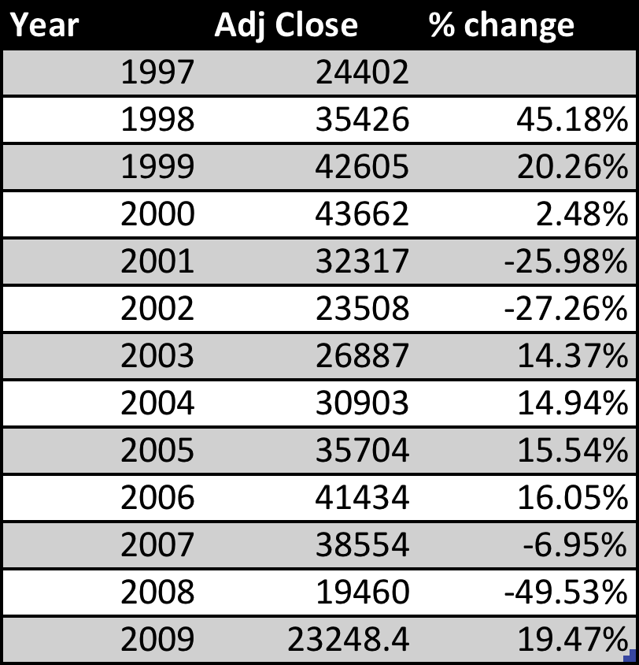
Figure 1: Returns on the FTSE MIB
The data from Figure 1 show how the Italian stock market actually underperformed if we take in consideration to buy in 1997 and sell in 2009, in fact the total return on the entire period using the formula $R=\frac{S1}{S0}-1$ is -4.73%. If than we take in consideration the two different periods T1 (before 1999) and T2 (after 1999), the returns on the index are respectively 45.18% and -45.43%. Moreover, if we don’t assume the holding period to be more that 1-year for each investment than taking the arithmetic averages of the returns, on the total period the return would be 3.21%. It is possible to say that this index reflect a quite unstable returns on the stock over the entire period. Figure 2 shows the trend of the price of the FTSE MIB index.
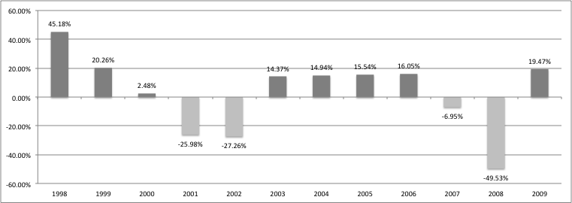
Figure 2: The trend of the FTSE MIB

Over the period the standard deviation has been calculated to be 22.26% a level that reflect the instability showed graphically in Figure 2.
The data showed before are only indicative of the general stock situation in Italy during the analyzed period; however, this data could not be used to for the calculation and comparison of ERP levels.
As a result, to carry out the comparison alternative data had to be adopted.

FTSE MIB all share:

Borsa Italiana.it (2014) provided historical data for a similar index to FTSE MIB, the Historical FTSE MIB All Shares. The difference with the previous is the fact that this index contains and summaries the average the performance of all the companies quoted on the Italian stock market. As a result, it is possible to argue that this measure is more reflective of the actual performance of the Italian Stock market.
Moreover, longer historical data have been found for this index giving us the possibility to have a larger amount of data.
Figure 3 shows the performance of the index and the calculations of the yearly returns.
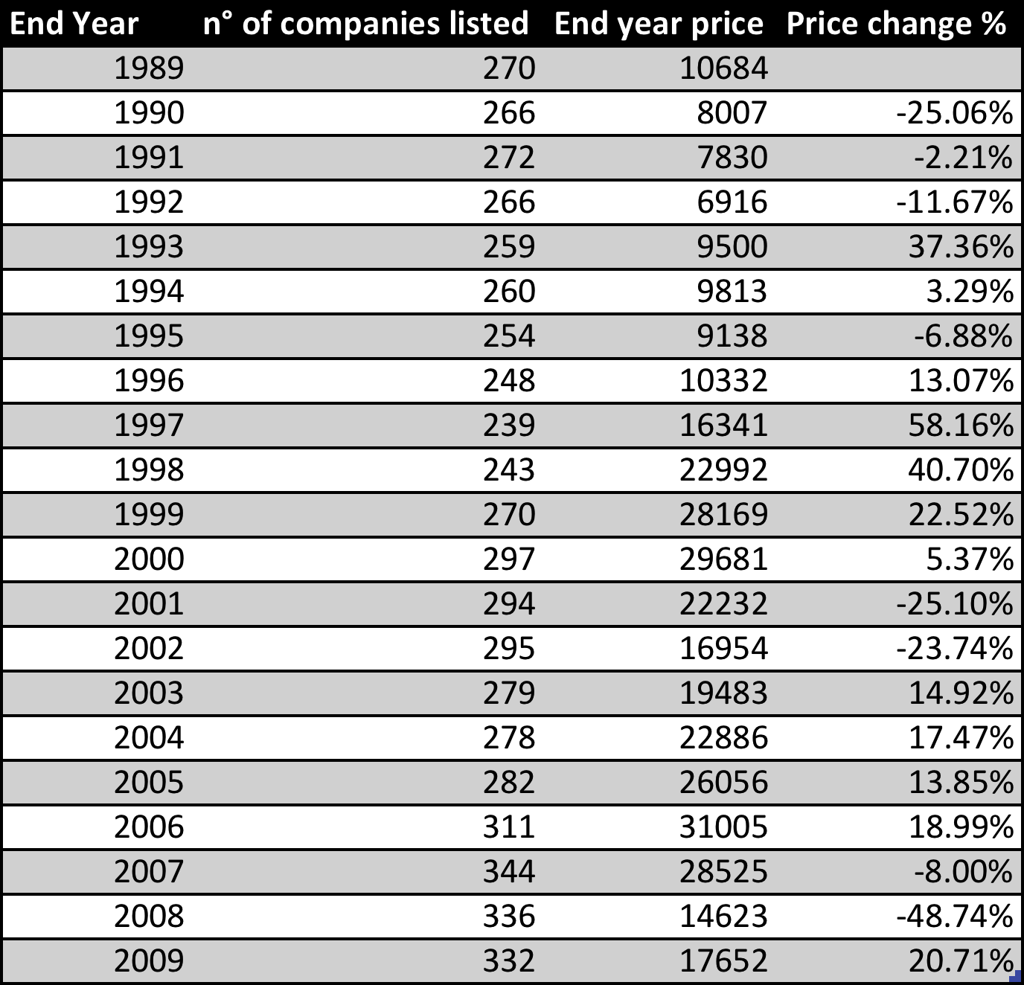
Figure 3: Returns on the FTSE MIB All Shares
As a result, again taking in consideration an investment made at in 1989 and hold until 2009 would have generated a return of 65.22%, however, taking in considerations the two different periods T1 (1989-1999) and T2 (1999-2009) the returns would be respectively 115.20% and -37.34%, showing again a high difference in the periods before and after the introduction of the Euro.
However, taking only the arithmetic averages of returns and not assuming to hold the investment in the periods, the results would be an average return of 5.75% over the entire period, an average return of 11.86% for T1 and an average return of 0.75% for T2. Figure 4 and 5 shows graphically the trend of the FTSE MIB All Shares Index.

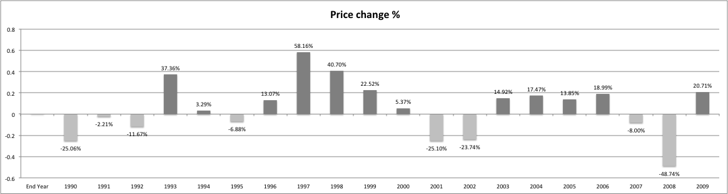
Figure 4: The Trend of the FTSE MIB All Shares
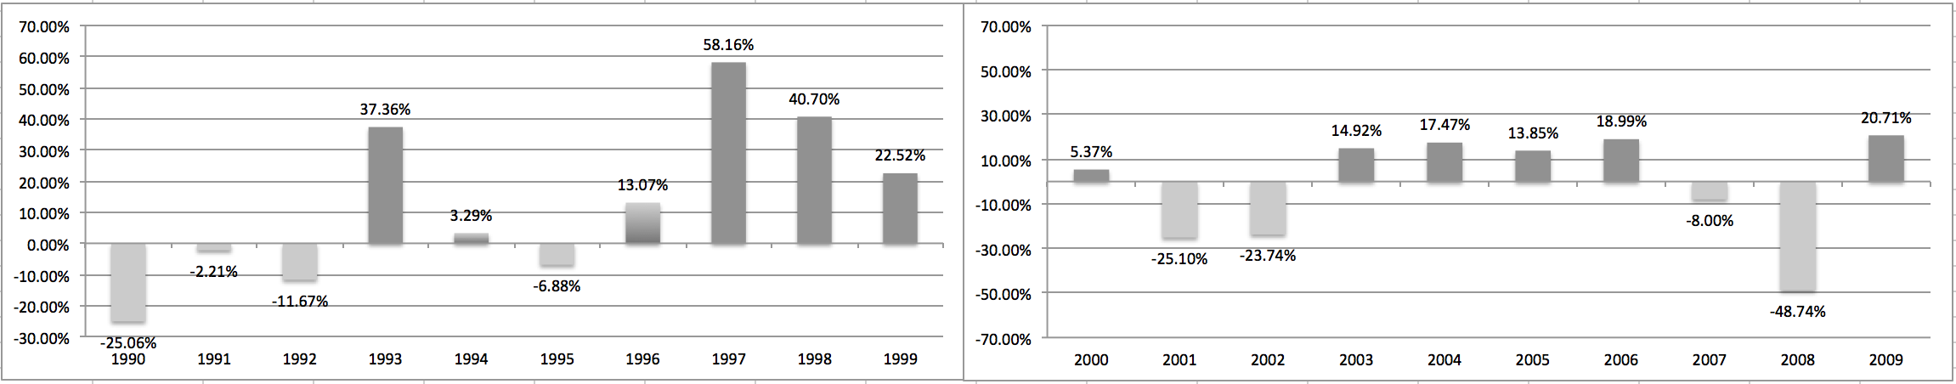
Figure 5: The Trend of the FTSE MIB All Shares in T1 and T2

It is again possible to notice that the level of return on the index is highly fluctuating during the entire period analyzed. Standard deviation has been calculated to be 25.60% taking all the period (1989-2009), while 27.76% in T1 and 23.82% in T2. These data reflect completely what has already been observed on the traditional FTSE MIB. In the analysis of historical returns the Italian Stock market reveled to be very unstable.

The Causes of the Fluctuations:

The causes of these fluctuations in the stock prices, are discussed from Grinblatt and Titman (2002), there are external and internal factors to take under considerations in estimating the causes of this instability.
As we are looking at returns in relation to price changes in the Italian stock index, it would be too difficult to identify internal factors for each of the companied facing part of the index itself, moreover, internal factors would anyway not affect the price of the entire index as they refer to company specific problems. On the other hand, it is possible to look at the main external factors that can have affected the stock index in the period of analysis.
However, first of all it is important to clarify a very important factor, in fact, according with Melle Hernandez (2002), after the introduction of the Euro in 1999 the correlation between European countries stock prices increased a lot. As a result, while for T1 (1990-1998) the analysis is done in relation to Italian macroeconomic factors, for T2 (1999-2009) the analysis is based on European macroeconomic factors so that it is possible to have a more accurate estimation of the causes of the fluctuation of stock prices.

T1:

In Figure 6 and 7 is possible to see how for T1 the Italian GDP growth rate reflects the instability of the Italian economy in the fluctuations of stock prices.
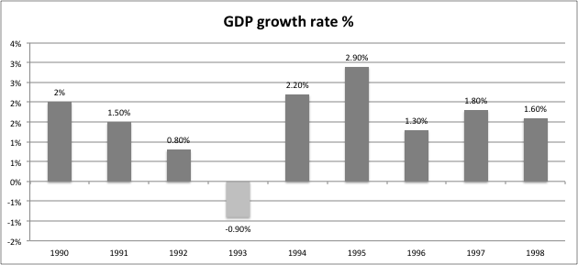
Figure 6: Italian GDP Growth Rate in T1
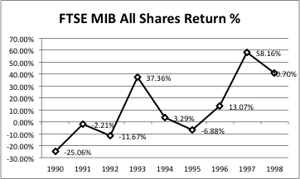
Figure 7: FTSE MIB All Shares Price Change in T1
Moreover, it also interesting to look at the data and understand that there are some historical fats that have had a strong effect on the stock returns.
Looking at the returns on stock in T1 it is possible to notice that from 1990 to 1995 the results are quite negative and this coincide with a period of political and economical instability in Italy.
If we than look at the period from 1995 to 1999 there is a period of economic stability in Italy which is reflected in higher returns in the stock market.

T2:

At this point it is necessary to look at the correlation of T2 stock prices with the main European macroeconomic indicators. Figure 8 shows the growth in percentage of the gross domestic product as average of the Euro area countries.
It is again clear that the economic situation in T2, after the introduction of the Euro is quite unstable and this is again confirmed by the fluctuating stock index prices (Figures 8 and 9). 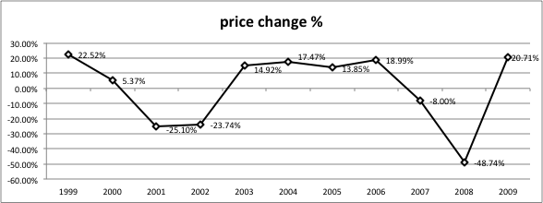
Figure 8: FTSE MIB All Shares Price Change in T2
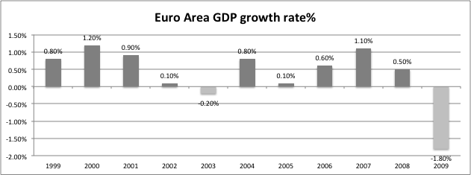
Figure 9: Italian GDP Growth Rate in T2

Again it is important to note that the result follow an unstable line due to external causes. Data from 2000 to 2002 are quite negative as a consequence of the Dot COM bubble crisis affecting the world market. Data from 2003 to 2006 are again positive as a result of a recovering period after the previous crisis. Than lastly, there is the sub-prime mortgage crisis between 2007 and 2008 that is showed again in the trend of the returns.
As a result, from this comparison it is clear that an unstable economic situation in the country is reflected in the movements of stock prices.
Multiple tragic events shocked the market especially in the last two decades and this of course generates contaminated figures.

Bonds Returns

The second main component of the ERP formula is the Risk Free Rate of Return. It has been demonstrated how treasury Bills/Bonds can be defined as risk free investments because the probability of country default is really low (with some exceptions for emergent markets and countries with high public debt as Greece) and the systematic or non-diversifiable risk can never be reduced to zero in any case.

10y BTP’s:

The main indicator that has been used in this research as risk free investment is the 10Y Italian bond also known with the acronym of generic BTP (Buono del Tesoro Poliennale). This type of bond can be issued with different times of maturity (3,5,10,15,30) and has a fixed annual coupon rate that is paid semiannually until its maturity. This type of bonds can also be traded on the market and acquired and sold in the entire period before maturity as their price are not fixed and move continually.
The first aim in this research according with the initial methodology was to use the main financial databases (Bloomberg and Reuters) to gather data of bond price fluctuations and coupon rates in order to calculate average returns. The problem was that financial databases, also in this case (as for stocks) do not provide so old information to have enough data.
However, Dipartimento delle Finanze (2015) provided a list of the average returns on the 10 year BTP’s available for the entire period useful for the analysis and calculation of ERP. Figure 10 shows the annual averaged returns on the 10y BTP’s.
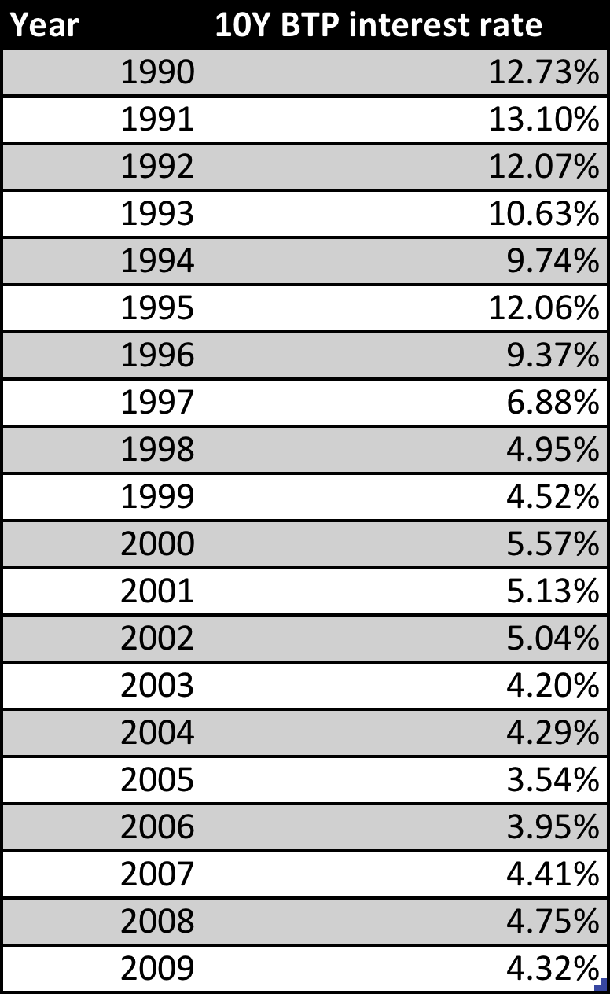
Figure 10: 10 Years Italian BTP Interest rate

The first aspect that needs to be evaluated and that can be observed just with a fast reading of the returns is that this returns decrease dramatically during the entire period creaing a big difference between T1 and T2. Figures 11 and 12 show graphically the drop in average returns in both the timeframes.
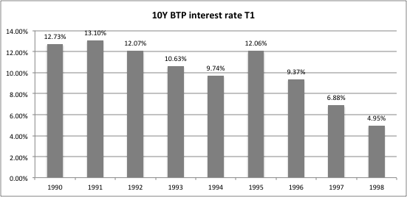
Figure 11: BTP Interest Rate T1
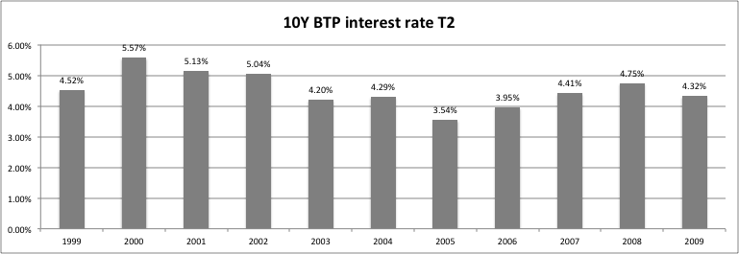
Figure 12: BTP Interest Rate T2
It is clear how since the introduction of the Euro the average return on BTP’s decreased drastically. This is also confirmed from the fact that the average return in T1 is 10.17% (quite high for a government bond), while the average return in T2 is 4.52% (lower but much higher then the returns nowadays). On the other hand T1 appears to be much riskier under the point of view of the investors having a standard deviation of the returns at 2.77% while T1 has a standard deviation of returns at 0.57%.
What it is possible to conclude from the analysis of the calculations above is that returns on bond where much higher in T1 than in T2.

The Causes of the Fluctuation:

An insight looking back at this data is that the approach to the imposition of rates of return on bonds of the Italian government had to change in order to adapt to the new currency and at the rest of the countries of the Euro area. This trend was observed in relation to stock prices already from Hernandez (2002). As a result a comparison between average returns on 10Y Italian bonds Return and average European 10y bonds return was needed to confirm this theory. Figure 13 and 14 show graphically the trend.

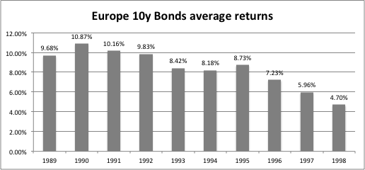
Figure 13: Europe 10 Years Bond Average Return in T1
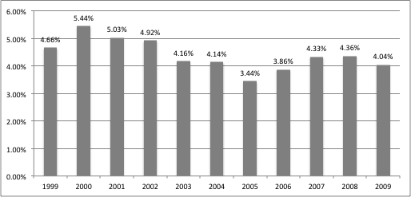

Figure 14: Europe 10 Years Bond Average Return in T2
The figures show a descendent trend since the introduction of the Euro in 1999 and confirms the initial theory by which the bond returns of European countries have become more correlated since the introduction of the Euro and this was done to create a uniform market for bonds less profitable but also less risky where the spreads have been drastically reduced.
At the end of the data analysis it has been possible to gather all the data to be used as Risk free Rate and has been confirmed that the introduction of the Euro affected the results.

Equity Risk Premium:

This section only comes as a result of the previous two. Having found out what are the yearly stock returns and the yearly returns on bond investments it is now possible to compute an ERP for the selected time frames.
The calculations of ERP have been carried out with two different methods. The first one called “average approach” is comparing the average ERP of T1 and T2 calculated as the difference between returns on stocks and bonds. This approach is more conventional and generally accepted.
The second approach is called “continue compounding approach” and turned to be less applicable due to the small size of the sample.

Data Analysis:

The initial results are quite particular, in fact, it is possible to observe that in period T1, 6 out of 9 years ended with a negative ERP scoring an average ERP of 1.69% that in terms of premium is anyway very low if looking at it under the prospective of an investor. On the other hand, in T2 has ben observed results that are even more disappointing, in fact, even if only 5 out of 11 years ended with a negative ERP the average return would have been -3.77%.
(Fernandez, 2004) observed how sometimes negative ERP can be found and calculated even if in economic terms a negative measure would appear as absurd and meaningless. In fact, ERP is a premium that an investor gets as a return in exchange of taking more risk investing in equity. However, when the stocks underperform the bonds in a given period as in this case, market trend benefits those investors more risk adverse. Figure 15 shows the results.

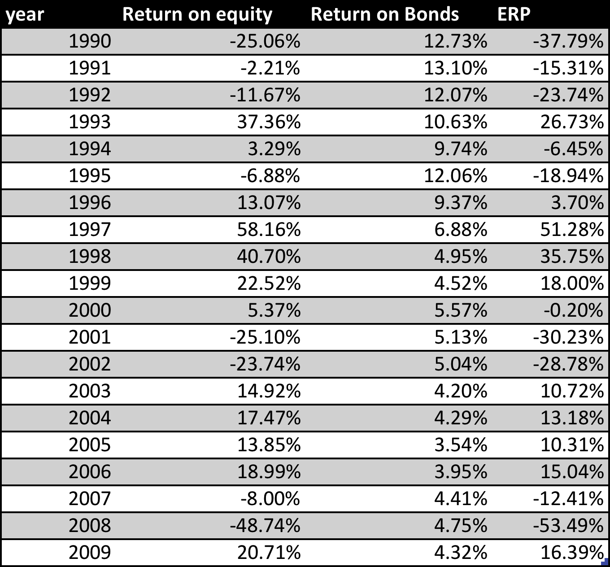
Figure 15: The Equity Risk Premiums IN T1 and T2
Another aspect that needs to be evaluated is the fact that the figures (reflecting the results from stocks and bonds) are quite volatile. In T1 the standard deviation of the results is equal to 30.08%, while in T2 data experienced a standard deviation equal to 10.31%. This instability of the equity premia is also reflected from the visual representation of the data in Figures 16 (T1) and 17 (T2).

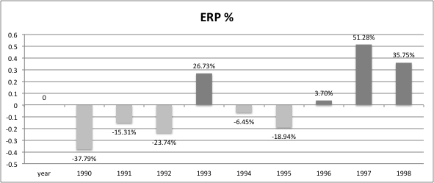
Figure 16: The Trend of the ERP in T1

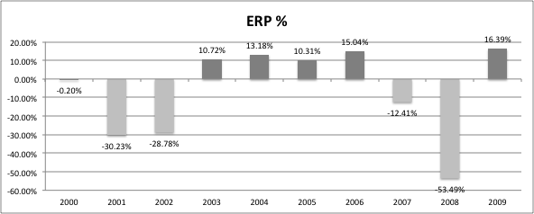
Figure 17: The Trend of the ERP in T2

Descriptive Statistics:

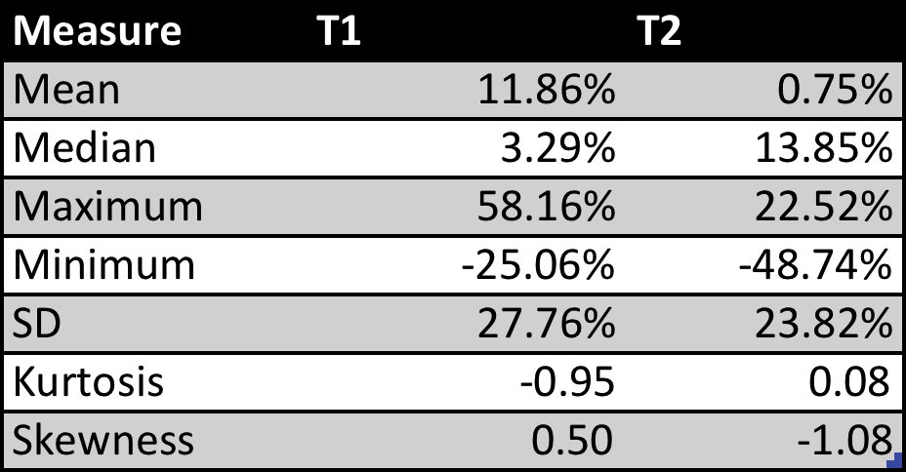

Figure 18: Descriptive Statistics of ERP Data

T Statistics Test:

Given the fact that the results are quite unstable it is necessary to carry out a t statistic test in order to understand the level of significance of the results and see if the average value actually differs across the two groups. The t test gives the possibility to understand if it is possible to reject or not the null hypothesis based on the above data.

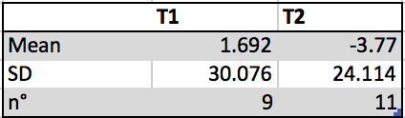
Figure 19: T-Statistic Test 1

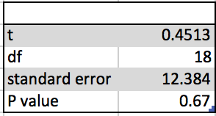
Figure 20: T-Statistic Test 2

Having carried out the t-test It is clear that a p value of 0.67 means that the difference between the means of the two sample periods, by conventional criteria is considered to be not significant. As a result the null hypothesis H0: $ERPt1=ERPt2$ cannot be rejected so it is accepted.

Continue Compounding Approach:

Given the fact that the analysis and calculations of ERP done year by year in both the periods have generated disappointing results, it has been interesting to conduct the research also in a different way in order to produce another set of results that can represent the trend of the market under another point of view.
The second approach has been inspired from a research made by Damodaran (2008). The research evaluates the concept that in estimating ERP, the return on stocks and bonds has to be yearly compounded in order to generate realistic results. In fact, in the previous calculations has been assumed that an investor were not holding the asset (stocks or bonds) for more than one year. This assumption is not always true; in fact, both bonds and stocks can in some cases be adopted as long-term investments.
However, Damodaran’s methodology appears to be only applicable to a set of data that is really consistent, so that, after the first 20 years of continue compounding all the ERP results to be positive. For this reason, when applying the same methodology, the results demonstrate that in this case the set of data available is not enough. Figure 21 shows the results assuming an initial investment of €100 at t0.
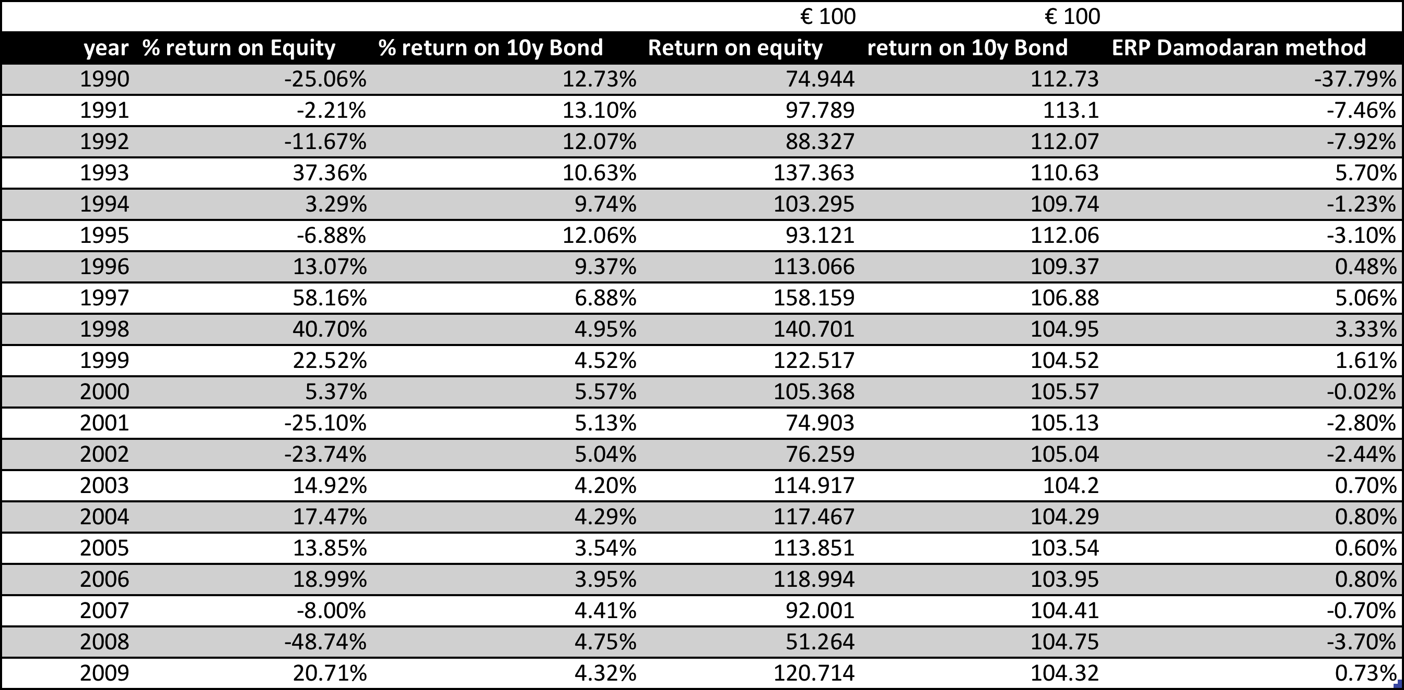
Figure 21: ERP's with Continue Compounding Approach
As a result, it is clear that the “compounding approach” can only be applied and worked with a larger set of data available. In this case cannot be significant in the formulation of a hypothesis.

ERP Implications:

In order to understand what are the implications of the results obtained it would make more sense to divide T1 and T2 in sub-periods. The analysis is carried out taking under considerations only the data gathered from the “average approach”.

T1 Sub-Period 1 (1990-1995):

From 1990 to 1995 the average ERP is -0.86%. The negative ERP in this period is reflecting the high instability and recession of the Italian economy together with high interest rates on bonds.

T1 Sub-Period 2 (1996-1998):

From 1996 to 1998 in Italy there is a period of quite fast economic growth. The country is going to enter the euro area, interest rate on bonds reduce gradually and more investors enter the market. As a result, ERP is highly positive at 37.31%.

T2 Sub-Period 1 (1999-2002):

From 1999 to 2002 we assist to one of the most difficult moment in the modern financial history. The burst of the Dot COM bubble hits the entire world drawing all the main financial markets in negative performance. As a result, the ERP of this period is negative at -5.24%.

T2 Sub-Period 2 (2003-2006):

From 2003 to 2006 it is possible to assist to a period of quite good financial stability and economic recovery from the previous crisis. The ERP for this period is really high at 16.31%.

T2 Sub-Period 3 (2007-2009):

From 2007 to 2009 it is possible to assist to another of one of the most negative periods of the modern financial history of the world. At the end of 2007 we all know that the sub-prime mortgage crisis hit first the US and than the rest of the world, affecting all the financial markets. As a result, the ERP in this period is -12.01%.

Given the SD of the results obtained and the events occurred in the last two decades, it is clear that becomes very difficult to formulate a theory.
The results of the t test in analyzing samples defined as not statistically relevant the difference between the means of the two periods (T1 and T2), for this reason, it is necessary not reject and so to accept the null hypothesis $H0: ERPt1=ERPt2$.

Conclusion & Recommendations

Results:

At the end of the analysis of the findings it is possible to look at the research and draw some conclusions.
This research has been carried out with the main objective of helping investors and especially Italian investors to understand how the introduction of the Euro changed the market in terms of profitability and risk.
Since the introduction of the Euro Italy suffered from a continuous economic downtrend that made lot of people starting to reflect upon the benefits and especially the disadvantages that Euro brought to Italy and Italian market.
As it would have been impossible to answer to all the questions on the Euro being good or bad for Italy in just one research, this paper is based on understanding if the riskiness and profitability of the market changed for investors in Italy since 1999.
The first step was to find out the best measure that would have been used as a main indicator of market performance. Looking at past projects, especially one inspiring paper from Damodaran (2008), it has been seen how Equity Risk Premium can be used to test the market.
Even if Damodaran’s methodology was really notable, it has been necessary to develop a different but equally effective methodology of calculation that led to more realistic results.
This quantitative analysis has been carried out with the aim of understanding what has been the effect of the Euro on the Equity Risk Premium in the Italian stock market. The research has than been focusing on two periods that have been than compared, T1 (1990 – 1998) and T2 (1999 – 2009), testing the null Hypothesis by which $ERPt1=ERPt2$.
The first measure needed for the calculations of ERP has been Stock returns that have been gathered calculating the yearly return on the FTSE MIB all share (an Italian stock index including all the traded shares).
After the calculation of the return on stock in both the periods there are no doubts on the fact that stocks performed without a clear defined trend in T1 than in T2 with both compounding and averaging approach. This is reinforced from the fact that in both the periods it has been experienced a particularly high standard deviation of returns meaning an unstable and fluctuating market in both the periods.
The causes of this fluctuations have been researched in the main macroeconomic factors, at national level for T1 and at international level for T2, as the correlation between European stock markets increased since the creation of the Euro area (Melle Hernandez, 2002).
The results gathered reflect the GDP growth rate levels in the given periods showing an instable situation at both national and international level causing an invasion of speculators in the market that make stock prices fluctuate.
The second measure needed for the calculation of the ERP has been the return on Italian 10 years Bonds (Risk free asset). Information regarding the Italian bonds has been gathered directly from the Italian stock market databases that provided the average return for this asset for all the years needed in the analysis.
While for Stocks returns there is not a clear trend and the result fluctuate during both the periods, in the case of the 10Y Bond it has been experienced a constant decreasing rate of return so that returns are much higher in T1 respect T2.
Again the answer to this trend is related with Hernandez (2002) theory. With the introduction of the Euro in 1999, European countries experienced a process of converging of the interest rates on their Bonds in order to be coherent with the rest of Europe and following the Maastricht regulations. As a result Italian bonds had to adapt to average European levels. With the creation of the Euro area and the European Central Bank as guarantee, the Italian bonds become even less risky as now the entire Euro area is behind these assets. This factor implied a lower return as the risk decreased.
Having both Stock and Bonds returns it has been possible to achieve the goal of the research and calculate the ERP.
The results showed that there is not an high difference in the ERP of the two periods as in both T1 and T2 it is possible to notice a stock market highly unstable leading to unstable results in ERP.
As a result, conducting a t test, the research did not reject the null hypothesis by which$H0: ERPt1=ERPt2$, meaning that the introduction of the Euro did not have a notable impact on the Italian ERP. However, It has been noticed a big difference between stock and bond market before and after the introduction of the Euro.
The only reason that can be attributed to the fact that ERP remained stable is that while return on bonds drastically decreased after the introduction of the Euro, the return on stock has been quite unstable due to some periods of crisis and some period of recover. The result is an almost invariant ERP between the two periods.
It is possible to argue that even if the Euro had a strong impact on the Italian Equity and Bond markets, due to some casual events this did not particularly change the level of profitability for Investors.

The Relevance of the Research:

The question that it is important to answer is how and why is this important for investors.
The answer is quite logical at this point. Since the introduction of the euro lot of change took place in Italy as in all the other countries of the Euro Area.
The economic recession experienced in Europe in the last years made people, especially investors think if it was or not a good idea to enter the Euro Area.
The only way to answer such a complicate question has been to conduct a research.
Italy has been used as an example, however, the same research could apply to all the European countries. The outcome of the this research helped to prove that even if in the recent years the economic situation was quite unstable, the introduction of the euro did not change financial variables in the investor’s environment. Entering the Euro area, Italy entered a bigger and more powerful organization that conferred safety to its Government assets and financial instruments, while the economic recession slowed the growth of the equity market. Even if this research failed in rejecting the null hypothesis, it is the proof that something changed with the introduction of the Euro and is not because of the Euro itself or investors made less profits, but, because the entire financial structure of Europe changed.

Limitations:

It is important to admit that the research had also some limitations. First of all, in the last two decades the financial trends followed a quite unstable line. Two of biggest financial crisis hit the world first in 2001 and than in 2007. For this reason, the results of ERP appeared to be contaminated from the events occurred.
Secondly, the period under analysis is only of 20 years (ten years before and after the introduction of the Euro), and It is clear that in order to generate fully trustable results is necessary to gather information from a period much larger of the one analyzed. The example given in the literature review from Damodaran (2008) showed how in order to formulate a proper statistical financial trend analysis of ERP in a country it is necessary to take under consideration a period of at least of 80 years. The reason why it has been impossible to expand the research to a larger period was the impossibility to have access to trustable data before 1989. The main financial databases (Bloomberg and Reuters) only provided a limited amount of historical data. The only way that was found possible was to have access to private financial databases. However, as this is an undergraduate research paper, also time and resources have been quite limited.
For this reason, the research has been adapted to analyze a shorter flow data and a new methodology was made in order to end up with realistic figures.
I am sure that with more time available and an extended amount of financial and statistical resources, this research could represent a starting point for a further more advanced research expanding the period of analysis to a larger number of years and also test the same hypothesis on more countries that experienced the a similar change in the official currency. With more research it could be possible to understand if there is a clear trend by which the adoption of the Euro as common currency in the Euro Area had the same effects on all the countries and affected the same way all the European investors.

In conclusion, this research opened a new argument of research for Italian and European investors. This project can be useful for future generations and government to fully analyze what are the effects of a change in the currency for investors in a country.
However, this research has reached also its goal of exploring in depth some critical aspects of the finance. A totally new and authentic methodology has been created to suit this research creating new ground for future researcher where to gain information and knowledge. This dissertation is not only a stand-alone piece as it answers a public interest question and open new arguments of discussion. At the end of this research my hope is to have helped the entire financial and non financial community to understand and explore a new argument and I also hope that this paper can inspire future young researchers to do their best in order to develop their knowledge and at the same time find new and unexplored questions to answer.

References

Bloomberg.com, (2016). FTSEMIB Quote - FTSE MIB Index. [online] Available at: http://www.bloomberg.com/quote/FTSEMIB:IND [Accessed 25 Feb. 2016].

Bodie, Z., Kane, A. and Marcus, A. (2010). Essentials of investments. 8th ed. Boston, Mass.: Irwin/McGraw Hill, p.298.

Borsaitaliana.it, (2014). indicatoridec - Borsa Italiana. [online] Available at: http://www.borsaitaliana.it/borsaitaliana/ufficio-stampa/dati-storici/indicatoridec.en_pdf.htm [Accessed 25 Feb. 2016].

Borsaitaliana.it, (2015). Why MTA? - Borsa Italiana. [online] Available at: http://www.borsaitaliana.it/azioni/mercati/mta/perche/perchemta.en.htm [Accessed 25 Feb. 2016].

Borsaitaliana.it, (2016). Historical Statistics - Borsa Italiana. [online] Available at: http://www.borsaitaliana.it/borsaitaliana/statistiche/statistiche-storiche/statistiche-storiche.en.htm [Accessed 25 Feb. 2016].

Brailsford, Tim, John C. Handley, and Krishnan Maheswaran. 'Re-Examination Of The Historical Equity Risk Premium In Australia'. Accounting & Finance 48.1 (2008): 73-97. Web.

Capiński, M. and Zastawniak, T. (2003). Mathematics for finance. London: Springer.

Cappiello, L., Hördahl, P., Kadareja, A. and Manganelli, S. (2006). THE IMPACT OF THE EURO ON FINANCIAL MARKETS. [online] Ecb.europa.eu. Available at: https://www.ecb.europa.eu/pub/pdf/scpwps/ecbwp598.pdf?54590acebd02d27aaac94aaae68d5a29 [Accessed 27 Feb. 2016].

Damodaran, Aswath. 'Equity Risk Premiums (ERP): Determinants, Estimation And Implications'.SSRN Electronic Journal (2008): n. pag. Web. 17 Oct. 2015.

Data.worldbank.org, (2016). GDP growth (annual %) | Data | Table. [online] Available at: http://data.worldbank.org/indicator/NY.GDP.MKTP.KD.ZG/countries/IT?page=3&display=default [Accessed 2 Mar. 2016].

Dimson, E., Marsh, P. and Staunton, M. (2002). Triumph of the optimists. Princeton, N.J.: Princeton University Press.

Dipartimento delle Finanze, (2015). MEF - Ministero dell'Economia e delle Finanze - Dipartimento del Tesoro - Principali Tassi di interesse. [online] Dt.tesoro.it. Available at: http://www.dt.tesoro.it/it/debito_pubblico/dati_statistici/principali_tassi_di_interesse/ [Accessed 25 Feb. 2016].

Duarte, Fernando, and Carlo Rosa. 'The Equity Risk Premium: A Review Of Models'. SSRN Electronic Journal 714 (2015): n. pag. Web. 17 Oct. 2015.

Elton, E. and Gruber, M. (1995). Modern portfolio theory and investment analysis. New York: Wiley, p.19.

Fernandez, P. (2004). Market risk Premium: required, historical and expected. iese business school, [online] pp.9-21. Available at: https://core.ac.uk/download/files/153/6536299.pdf [Accessed 3 Mar. 2016].

FTSE Russell, (2016). FTSE metodologia - Borsa Italiana. [online] Borsaitaliana.it. Available at: http://www.borsaitaliana.it/azioni/tutti-gli-indici/metodologiadicalcolo/ftse.en_pdf.htm [Accessed 25 Feb. 2016].

Grinblatt, M. and Titman, S. (2002). Financial markets and corporate strategy. Boston: McGraw-Hill Irwin.

investing.com Italia, (2016). FTSE MIB Storico Tassi - Investing.com. [online] Available at: http://it.investing.com/indices/it-mib-40-historical-data [Accessed 25 Feb. 2016].

Lexicon.ft.com, (2016). Risk-Free Asset Definition from Financial Times Lexicon. [online] Available at: http://lexicon.ft.com/Term?term=risk_free-asset [Accessed 27 Feb. 2016].

Melle Hernandez, M. (2002). The Euro Effect on the Integration of the European Stock Markets. SSRN Electronic Journal.

Sdw.ecb.europa.eu, (2016). Euro area (changing composition) - Benchmark bond - Euro area 10-year Government Benchmark bond yield - Yield - Euro, provided by ECB - Quick View - ECB Statistical Data Warehouse. [online] Available at: http://sdw.ecb.europa.eu/quickview.do;jsessionid=CCDB579D4D0B09D8B05F742CDFFBFF2A?SERIES_KEY=143.FM.M.U2.EUR.4F.BB.U2_10Y.YLD&start=1980&end=2015&submitOptions.x=61&submitOptions.y=4&trans=N [Accessed 2 Mar. 2016].

Tradingeconomics.com, (2016). Italy Stock Market (FTSE MIB) | 1997-2016 | Data | Chart | Calendar. [online] Available at: http://www.tradingeconomics.com/italy/stock-market [Accessed 25 Feb. 2016].

Uk.finance.yahoo.com, (2016). FTSEMIB.MI Historical Prices | FTSE MIB Stock - Yahoo! UK & Ireland Finance. [online] Available at: https://uk.finance.yahoo.com/q/hp?s=FTSEMIB.MI&b=01&a=00&c=2006&e=31&d=11&f=2009&g=m [Accessed 25 Feb. 2016].

Welch, Ivo. 'Views Of Financial Economists On The Equity Premium And On Professional Controversies'. The Journal of Business 73.4 (2000): 501-537. Web.

Appendix:

Appendix 1:

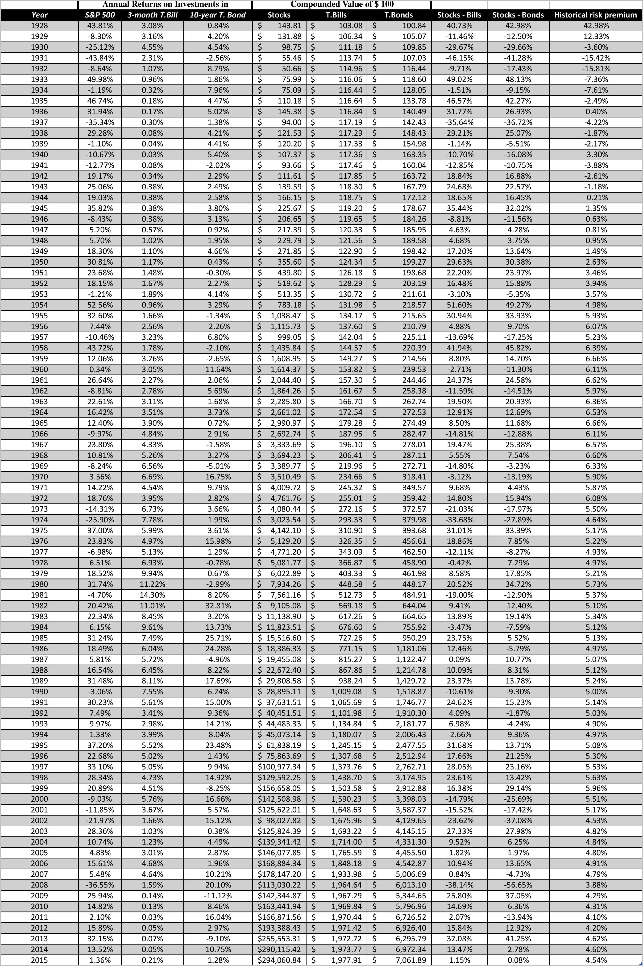

Appendix 1 contains a table representing the work made from Damodaran (2008) in which the author used his own methodology to calculate the ERP in United States in a time frame of 80 years.
The same methodology has been an inspiration for my research and a point of start to create my personal methodology.

Appendix 2:




Appendix 3:

